Project Development Phase
Model Performance Test

Date | 11-02-2026
Team ID | LTVIP2026TMIDS57051
Project Name | Exploratory Analysis of Rainfall Data in India for Agriculture.
Maximum Marks

Model Performance Testing:
Project team shall fill the following information in model performance testing template.
S.No. | Parameter | Values | Screenshots
 | Model Summary | - | -
 | Accuracy | Training Accuracy – 0.82  Validation Accuracy -0.78 | 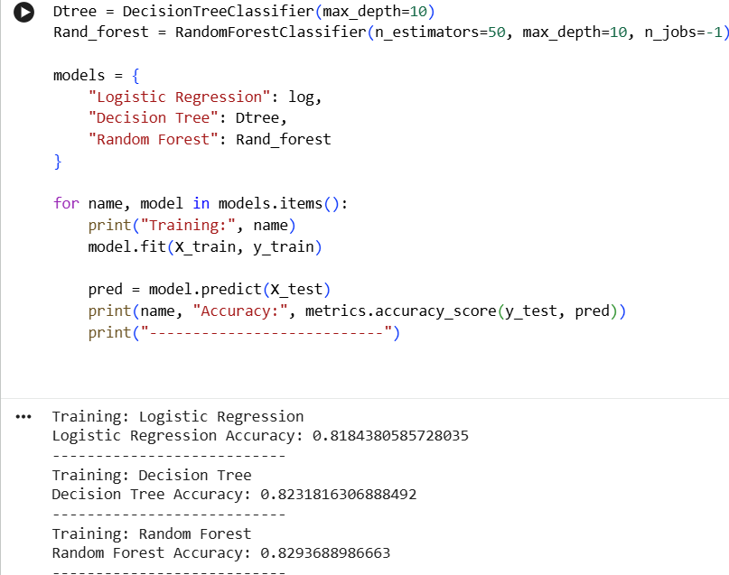
3. | Fine Tunning Result( if Done) | Validation Accuracy -0.78

